Title: | Door Control Module  SW Architecture < DoorCtrlModule>

History
Issue status  (Index) | Maturity/Date  (draft/invalid/valid)  (dd-mmm-yyyy) | Author  Department | Check/Release  Department | Description
1.0 | Draft  26-Ago-21 | Vicente Guerrero | Vicente Guerrero | Creation of the document

Table of Contents
1 Purpose 3
2 Definitions and abbreviations 3
3 Realization constraints and targets 3
4 SW Functional Architecture 3
4.1 Table of functions 3
4.2 Table of functional Interfaces 5
4.3 Functional Interface 5
4.4 Functional Interaction 7
5 SW Physical Architecture 8
5.1 Physical Decomposition 8
5.2 Table of SW components 10
5.3 Table of Physical Interfaces 10
5.4 Physical Interfaces 11
5.5 Physical Interaction 12
5.6 Describe Dynamic Behavior 14
5.6.1 OS tasks 14
5.6.2 Interrupt Handling 15
5.6.3 Power Modes 15
5.7 Synchronization Mechanisms 16
6 Function to Physical Allocation 16
7 SW Requirements Allocation 17
8 SW Integration Plan 17
9 Functional Safety 17

Purpose
This document will describe the architecture of the system for the Door Control Module Project.

Definitions and abbreviations
Definitions
Function | A logical set of steps, operations or processes
Component | A piece of the system that can make operations and have attributes
Block definition Diagram | A diagram that shows the relations and data flow between functions or components in a SW Architecture
Sequence Diagram | A diagram that shows the dynamic interaction between functions or components in a SW Architecture step by step.
Decomposition | Is the process of taking apart a general object and classify every piece or “Component” from it in an abstraction layer.

Abbreviations
HMI (Human Machine Interface)
LED (Light Emmiter Diode)
RGB (Red-Green-Blue Led)
References
N° | Document name | Reference
1 | SW Requirements | Location at “ ../V-Cycle Process/1.0 Requirements/Traceability Matrix Template.xls”

Realization constraints and targets

With this architecture, it is expected to have a better understanding of SW Requirements and

SW Functional Architecture

Table of functions
Function Name | Description
1 ControlLockDoor | This function will lock the corresponding door
2 ControlWindow | This function will control an operation with the corresponding door
3 ManageHMI | This function will manage all operations and requests from the Human Machine Interface
4 ManageManualMode | This function will manage the Manual Mode of the System
5 ManageRemoteMode | This function will manage the Remote Mode of the System
6 DetermineWindowPosition | This function will determine the window position of the corresponding window
7 ReportWindowPosition | This function will report the window position of the corresponding window
8 RequestWindowControl | This function requests the window control operation on the CAN Network
9 RequestDoorLocking | This function requests the door locking operation on the CAN Network
10 DetermineDoorLockPosition | This function will determine the Door Lock position from the corresponding door.
11 ReportDoorLockPosition | This function will report the Door Lock position from the corresponding door.
12 ReportBlockWindow | This function will report the block window operation from the corresponding door.
13 DetectObstaclesOnWindow | This function will detect any obstacles in a window
14 CancelWindowActuation | This function will cancel the Window Actuation
15 CloseWindowActuation | This function will close the corresponding window
16 OpenWindowActuation | This function will open the corresponding window
17 LockDoorActuation | This function will lock the door actuation on the corresponding Door
18 TurnOnLED | This function will Turn On an LED
19 TurnOffLED | This function will Turn Off an LED
20 UnlockDoorActuation | This function will unlock a door the corresponding door.
21 DetermineButtonStatus | This function will determine the button status from the corresponding button
22 DetermineButtonPressType | This function will determine the button press type from the corresponding button.
23 BlockWindow | This function will block a window
24 ReportAntipinchSignal | This function will report the antipinch signal
25 DetectAntipinchEvent | This function will detect the antipinch event
26 ReportDoorLockStatus | This function will report the Lock status from the corresponding Door
27 DiscardButtonGlitch | This function will discard glitches on the corresponding button
28 DiscardSwitchGlitch | This function will discard glitches on the corresponding switch
29 DetermineSwitchStatus | This function will determine the switch status from the corresponding switch
30 DetermineSwitchPressType | This function will determine the switch press type from the corresponding switch.
31 ChangeRGBColor | This function will change the color from the RGB Led
32 ChangeLEDBARAnimation | This function will change the animation on the 10RED LED BAR
33 DisableDoorLocking | This function will disable the Door locking function on the corresponding door
34 DisableWindowControl | This function will disable the window control operation on the corresponding window
35 ManageErrors | This function will manage Errors on the system (such Button Stuck)

Table of functional Interfaces
Signal/Event | Description
1 DoorLockStatus | This signal is sent by the function DetermineDoorLockStatus
2 HMIRequest | This signal contains a request from ManageHMI function
3 ManualModeRequest | This signal contains a request from Manual Mode Operation
4 RemoteModeRequest | This signal contains a request from Remote Mode Operation
5 WindowPosition | This signal contains the window position
6 DoorLockPosition | This signal contains the door lock position
7 BlockWindowRequest | This signal contains a request to block the window
8 DoorLockingRequest | This signal contains a request to perform a Door Locking Operation
9 ObstacleDetected | This signal informs that an obstacle was detected
10 WindowActuation | This signal activates the window actuation for opening or closing the window
11 DoorLockActuation | This signal activates the DoorLock Actuation
12 LEDStatus | This signal contains the Led status: ON or OFF
13 ButtonStatus | This signal contains the Button Status: Pressed, not pressed
14 ButtonPressed | This signal contains the button and the press type
15 WindowBlocked | This signal indicates if the window was blocked
16 AntipinchSignal | This signal indicates that there was an AntipinchSignal
17 AntipinchEvent | This signal reports an Antipinch Event
18 ButtonGlitch | This signal reports a button glitch
19 SwitchGlitch | This signal reports a switch glitch
21 SwitchStatus | This signal contains the status of the switch
22 SwitchPressed | This signal indicates that a switch was pressed (activated)
23 RGBColor | This signal indicates the Color of the RGB
24 LEDBARAnimation | This signal indicates the LEDBar Animation that has to be performed
25WindowControlRequest | This signal contains a request for Window Control
26 DoorLockErrorSignal | This signal reports an error on Door Locking
27 WindowErrorSignal | This signal reports an error on Window Control
28 WindowDisableRequest | This signal contains a request for disabling the Window Control
29 DoorLockDisableRequest | This signal contains a request for disabling the Door Lock
30 UnlockDoorActuation | This signal activates the Unlock Door Actuation
31 HMIRequest | This signal contains a request from the HMI

Functional Interface
The next Block Definition Diagram shows the communication between functions from the table where every block represents a Function, and the arrows represent the Data Signals.

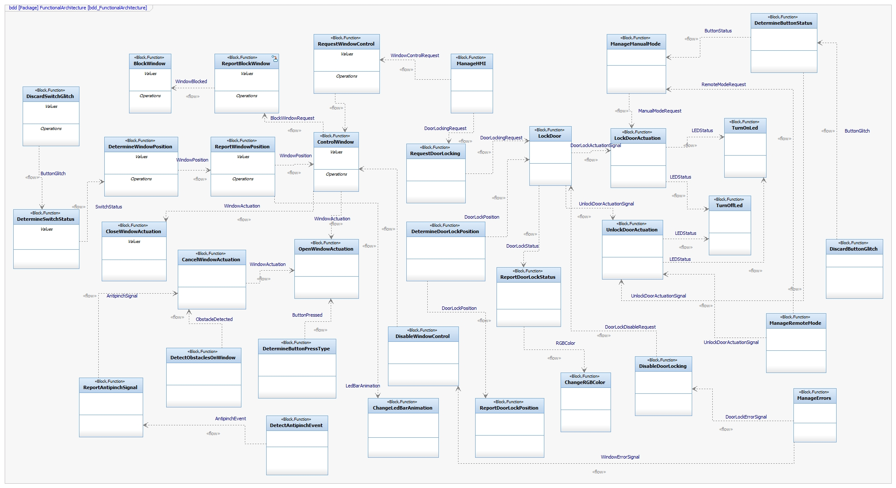

Functional Interaction

The following Sequence Diagrams show two functions and their interactions:
Door Locking Sequence. Is shows only the process for Door Lock and Door Unlock when a request is sent by HMI.
Window Control Sequence. It shows only the process for Window Open and Close when a request is sent by HMI.

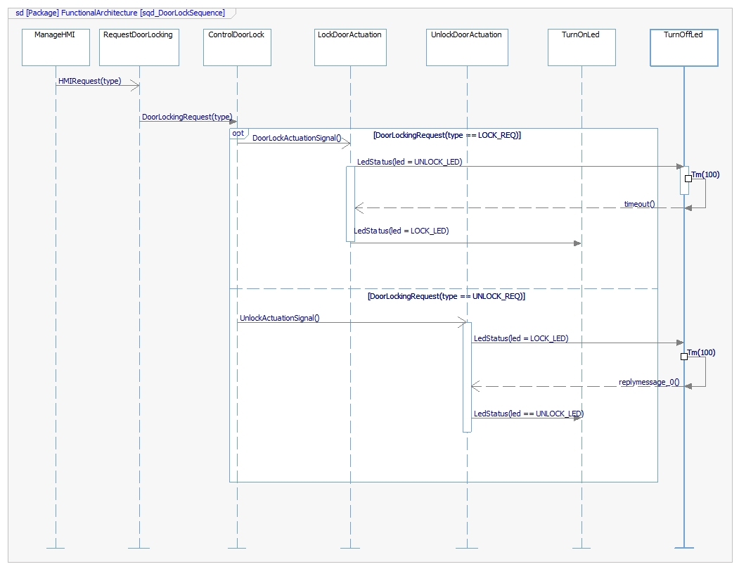

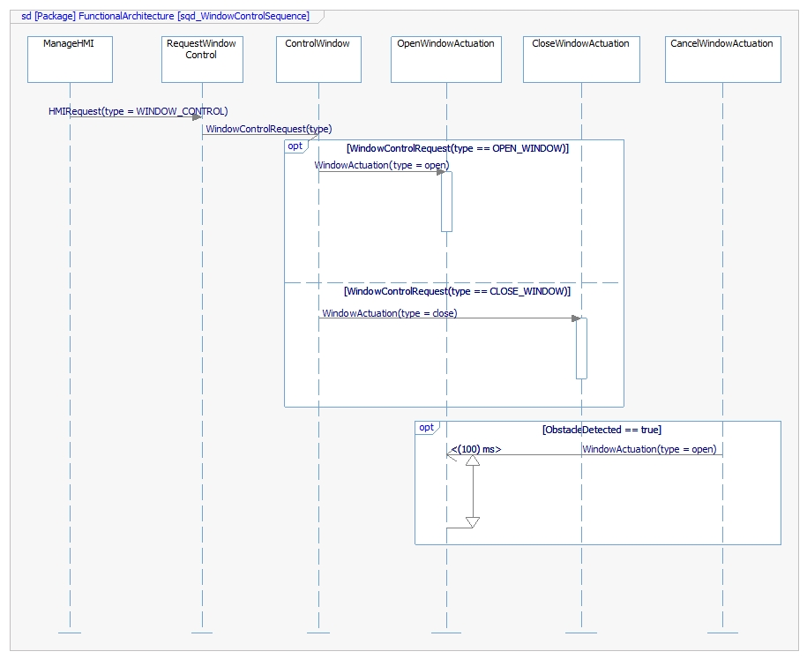

SW Physical Architecture

Physical Decomposition
The next Block Definition Diagram shows the SW Decomposition. There are three main layers: MCU_Layer. Includes all the Components that are related to the main communication with the microcontroller.
HW_Layer. Includes all the Components that are related to external Hardware Control of the system.
APP_Layer. Includes all the Components that are related to the main functions of the system solution.
The size of the SW will be 83 kB.

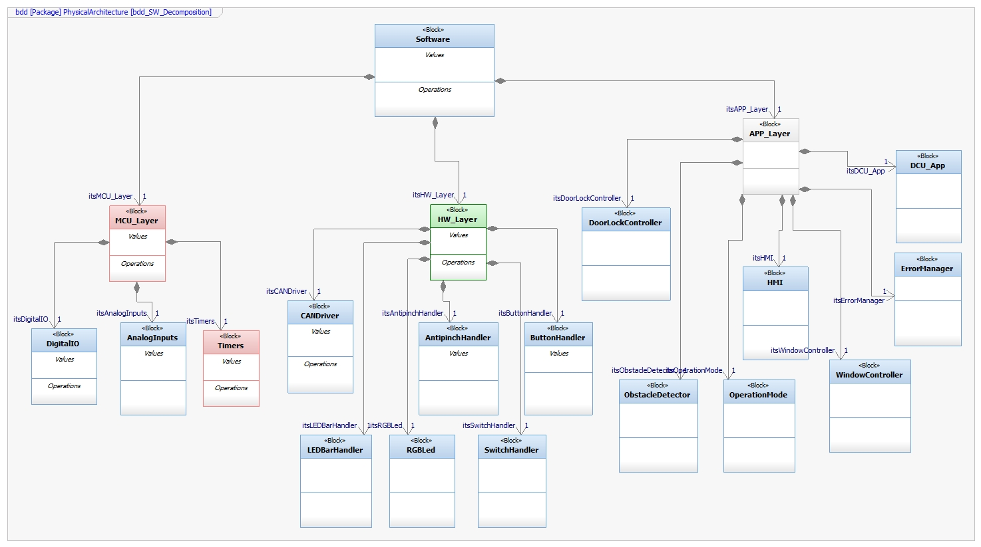

Table of SW components
SWC Name | Description | Estimated Size (KB)
WindowController | This component will make all operations related to WindowControl | 15
LEDBarHandler | This component will handle the animations on the LEDBar using the digital outputs. | 5
RGBLed | This component will control the state of LEDs of the RGBLED | 5
AntipinchHandler | This component will handle the antipinch event and detection using the Analog Inputs. | 3
ObstacleDetector | This component will report and handle the obstacles detection using the antipinch events | 1
ButtonHandler | This component will handle the buttons for Manual Mode in DoorLocking | 5
SwitchHandler | This component will handle the switches for the Window Position Determination | 5
DoorLockController | This component will make all operations related to Lock Door, Unlock Door, Report Door Status and determine Door Lock position. | 12
ErrorManager | This component will report Errors signals according to Door Lock and WindowControl operations. | 3
HMI | This component will handle the requests from HMI | 5
OperationMode | This component will handle the operation Mode requests | 5
DigitalIO | This component will handle Digital Inputs and Outputs to the Microcontroller Unit | 3
AnalogInputs | This component will handle Analog Inputs to the Microcontroller Unit | 3
CANDriver | This component will handle the CAN Frames to the CAN Network. | 6
Timers | This component will handle timeouts and time intervals to the Microcontroller Unit | 7

Table of Physical Interfaces
Operation | Description
iDoorLockControl | This interface will connect the DoorLockController with the rest of the dependant components
iWindowControl | This interface will connect the WindowController with the rest of the dependent components.
iRGB | This interface will connect the RGBLed with low level components such as DigitalIO, Timers and High level components like DoorController.
iLedBar | This interface will connect the LedBarHandler with low level components such as DigitalIO, Timers and High level components like WindowController
iButtonHandler | This interface will connect the ButtonHandler with low level components such as DigitalIO, Timers and High level components like DoorController
iSwitchHandler | This interface will connect the SwitchHandler with low level components such as DigitalIO, Timers and High level components like WindowController.
iAntipinchSignal | This interface will connect the AntipinchHandler with low level components such as AnalogInput, Timers and High level components like ObstaclesDetector and WindowController.

Physical Interfaces
The following Block Definition Diagram shows how all the Components are connected and the interfaces between all of them.

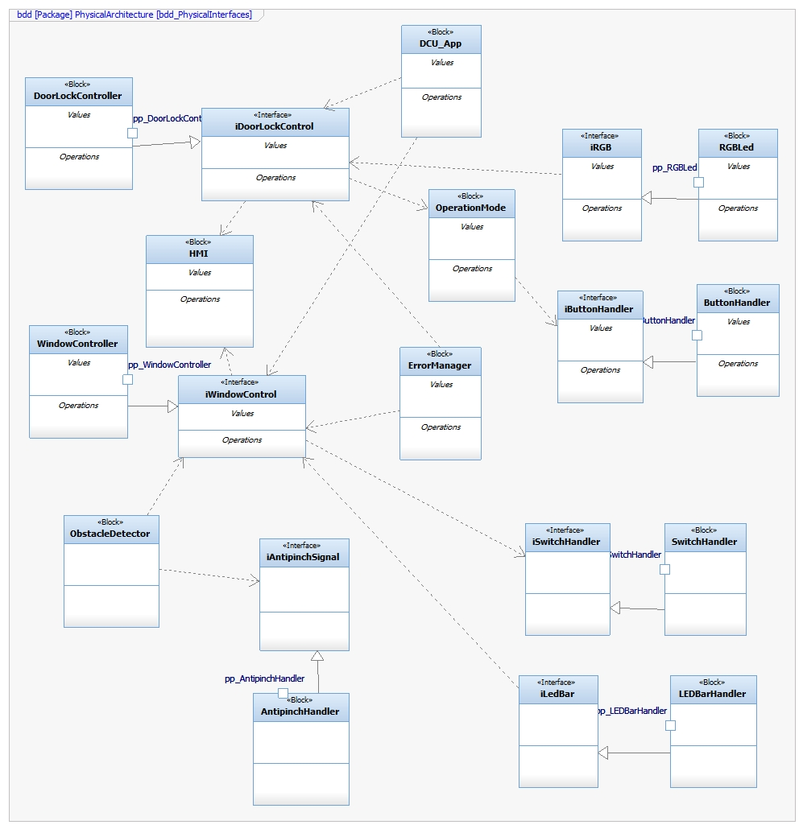

Physical Interaction
.
The following Sequence Diagram shows two processes from two main Components:
WindowController.
DoorLockController.

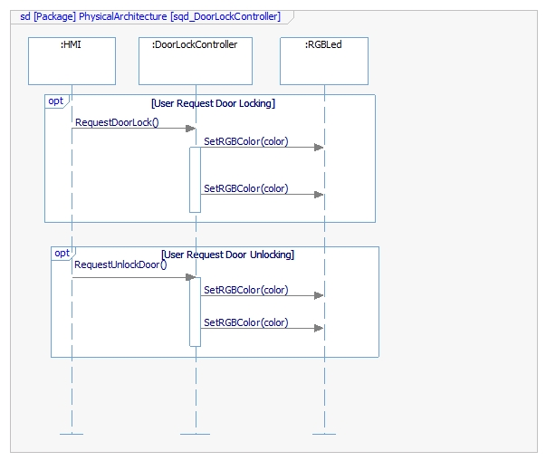

Describe Dynamic Behavior

OS tasks
OS task | Description | Periodicity | Period | Priority | CPU Load
ButtonMonitor | This task will monitor the button status | 100 ms |  | MEDIUM | 10 %
AntiPinchMonitor | This task will monitor if there was an antipinchEvent | 10 ms |  | HIGH | 15 %
SwitchMonitor | This task will monitor the switches status | 100 ms |  | HIGH | 10 %
WindowActuationTask | This task will perform the actuation of the window | 500 ms |  | HIGH | 25 %
DoorLockActuationTask | This task will perform the actuation of the door lock | 500 ms |  | HIGH | 25 %

Interrupt Handling
ISR task | Description | Priority | CPU Load
AntipinchEvent | This interrupt will be executed when the Analog Inputs has an antipinch value | HIGH | 2 %
ButtonPressedEvent | This interrupt will be executed when the Digital Input for the button is activated. | MEDIUM | 1 %
SwitchActivatedEvent | This interrupt will be executed when the Digital Input for the switch is activated. | MEDIUM | 1 %

Power Modes

Low Power Mode
In this solution, there will not be implemented the Low Power Mode.

High Power Mode
All functions and operations will be performed at High Power Mode.

Synchronization Mechanisms
Critical sections will be implemented in order to protect value from shared data such as ButtonStatus, SwitchStatus, WindowPosition, DoorLockPosition.

Function to Physical Allocation

Function | SW component | Clarification
BlockWindow | WindowController
CancelWindowActuation | WindowController
ChangeLedBarAnimation | LEDBarHandler
ChangeRGBColor | RGBLed
CloseWindowActuation | WindowController
ControlDoorLock | DoorLockController
ControlWindow | WindowController
DetectAntipinchEvent | AntipinchHandler
DetectObstaclesOnWindow | ObstacleDetector
DetermineButtonPressType | ButtonHandler
DetermineButtonStatus | ButtonHandler
DetermineDoorLockPosition | DoorLockController
DetermineSwitchPressType | SwitchHandler
DetermineSwitchStatus | SwitchHandler
DetermineWindowPosition | WindowController
DiscardButtonGlitch | ButtonHandler
DiscardSwitchGlitch | ButtonHandler
LockDoorActuation | DoorLockController
ManageErrors | ErrorManager
ManageHMI | HMI
ManageManualMode | OperationMode
ManageRemoteMode | OperationMode
OpenWindowActuation | WindowController
ReportAntipinchSignal | AntipinchHandler
ReportBlockWindow | WindowController
ReportDoorLockPosition | DoorLockController
ReportDoorLockStatus | DoorLockController
ReportWindowPosition | WindowController
RequestDoorLocking | DoorLockController
RequestWindowControl | WindowController
TurnOffLed | RGBLed
TurnOnLed | RGBLed
UnlockDoorActuation | DoorLockController

SW Requirements Allocation
Please refer to SW Requeriments traceability Matrix shows the requirement allocation to Components from Physical Architecture.

SW Integration Plan

Integration Step | Description | SW components | Comments
MCU_Layer Integration | The first integration part will be the components from the MCU_Layer. This will facilitate the integration of High level components. | DigitalIO, AnalogInputs, Timers
HW_Layer Integration only components | The second part will be the Integration of HW_Layer components but not interfaces. Components are built and the operations are set from the inside. | CANDriver, LedBarHandler, RGBLed, AntipinchHandler, SwitchHandler, ButtonHandler
HW_Layer Integration Interfaces | The third part will be the Interfaces from the HW_Layer. This will make easier to connect the APP_Layer components. | iLedBar, iRGB, iSwitchHandler, iAntipinchSignal
APP_Layer Integration Interfaces | The fourth parth will be the Interfaces of the APP_Layer. This will help to combine with the rest of the software and the components. | iDoorLockControl  iWindowControl
APP_Layer Integration Components | The final Step will be the integration of the APP_Layer components in order to finish with the SW Solution. | DoorLockController, WindowController, ObstacleDetector, OperationMode, ErrorManager, DCU_App

Functional Safety
This chapter will be fill during Module 5

